Ingested plastic drive physiological variation independent of body mass in Sable Shearwater fledglings

Jennifer L. Lavers^{1,2,3,}, Alix M. de Jersey³, Jack Rivers-Auty^{3,4}, Alexander L. Bond^{2,3}

¹Gulbali Institute, Charles Sturt University, Wagga Wagga, New South Wales, 2678, Australia
²Bird Group, The Natural History Museum, Tring, Hertfordshire, HP23 6AP, United Kingdom
³Adrift Lab, Underwood, Lutruwita/Tasmania, 7268, Australia
⁴Te Kaupeka Oranga | Faculty of Health, University of Canterbury | Te Whare Wānanga o Waitaha, Christchurch 8140, New Zealand
*Corresponding author: Jennifer.Lavers1@nhm.ac.uk

ABSTRACT
Plastic pollution is increasing rapidly and poses significant risks to wildlife health. Seabirds are particularly vulnerable because floating plastics resemble prey and contain diverse chemicals that can leach into digestive tissues. We revisited blood data and ingested plastic loads from Sable Shearwater Ardenna carneipes fledglings collected in 2014 and compared these with new data from 2025 to assess changes in physiological responses over time. Fledglings in 2025 exhibited substantially higher plastic burdens, which were closely associated with disruptions in electrolyte balance, including decreased sodium, chloride, and calcium and increased potassium and carbon dioxide. These patterns are consistent with impaired renal function and were stronger than those observed in 2014, likely due to the wider range and greater mass of plastic ingestion in 2025. Glucose concentrations declined with increasing plastic mass, and mediation analysis showed that body mass did not account for this relationship. The findings indicate that direct effects of plastic exposure, rather than nutritional status, drive the observed physiological impairments. The worsening of key health indicators over the past decade highlights the need for continued long term monitoring and for research into the mechanisms by which plastics contribute to kidney dysfunction and metabolic disruption in marine wildlife.

Graphical Abstract
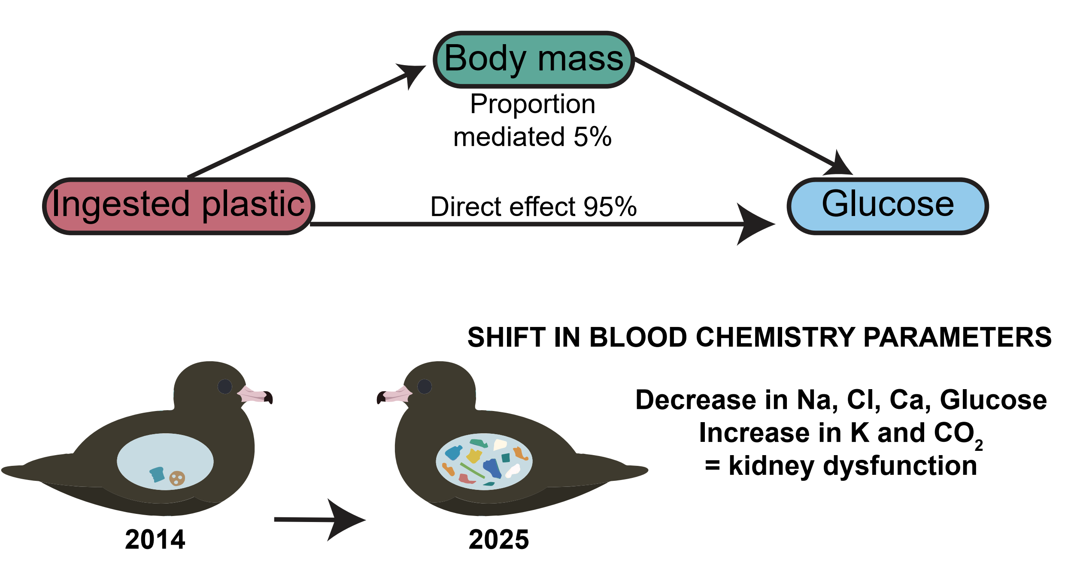

KEYWORDS: Ardenna carneipes, Blood parameters, Long-term monitoring, Plastic ingestion, Seabird sentinel, Shifting baselines

Introduction
Plastic pollution of terrestrial and aquatic environments is a rapidly worsening environmental catastrophe ¹. Each year, new research provides another metric by which we measure the growing plastic ‘smog’ that is now ubiquitous across our planet ^{2, 3}. Each statistic tells an important and harrowing story. For example, retrospective analyses have demonstrated that in less than the average human lifetime, society has produced 10,000 teragrams (10¹⁶ g) of fossil fuel–based polymers ⁴, roughly equivalent to 167× the mass of all humans on Earth. Despite this hyperabundance, contemporary analysis indicates plastic production is growing rapidly at a rate of around 3% per year ⁴ and under a business-as-usual scenario, the amount of plastic being released into the environment annually could double by 2040 ⁵. Plastics of all types and sizes have already been documented in a diversity of wild species ⁶ and humans ⁷, with some wildlife now ingesting so much plastic that their bodies and breeding sites are considered ‘reservoirs’ for the world’s waste ^{8, 9}. Even if it were possible to halt plastic emissions into the environment tomorrow, the quantity would unfortunately continue to increase as legacy items fragmentation into smaller pieces ^{5, 10}.

Of the estimated 350,000 chemicals currently being synthesised as part of global manufacturing and agriculture ¹¹, at least 10,000 are commonly used in plastics production ¹². Rarely is only one chemical used in plastics. Instead, plastics are mixtures of diverse components – often referred to as ‘chemical cocktails ¹³ – with various chemicals added as processing aids to enable production (e.g., lubricants) or as additives that impart specific properties (e.g., flame retardants; ¹⁴). More than 2,400 of the chemicals detected in plastic products have been identified as substances of potential concern due to their environmental toxicity, persistence, and ability to bioaccumulate in food webs, yet more than 900 of these substances have been approved for use in plastic food packaging ¹². Once in the environment, plastics accumulate additional chemicals which sorb onto the surface over many years or decades ^{15, 16}. When ingested by wildlife, exposure of plastics to the digestive environment (i.e., elevated temperatures, high acidity) can liberate many chemicals, releasing them into the animal’s blood stream ¹⁷.

Plastics also fragment readily into smaller size fractions, resulting in physical damage, behavioural alteration, and physiological impairment in a variety of tissues, even in apparently healthy individuals ¹⁸⁻²⁰. While many of these smaller fragments may be passed through the digestive tract ^{21, 22}, they may have already resulted in damage to the gastro-intestinal tract ²³.

As apex predators, seabirds are particularly vulnerable to ingesting plastics, and being exposed to plastic-associated chemicals, because items floating on the ocean surface can resemble prey ^{24, 25}. The consumption of plastic has been linked with a range of negative health consequences, including reduced body size ²⁶, scarring and fibrosis of the stomach, liver and kidneys ^{18, 27} and neurological disorders ¹⁹. The relationship between ingested plastic and blood chemistry parameters has also been investigated with mixed findings. For example, ingested plastic did not influence the blood chemistry of Wedge-tailed Shearwaters (Ardenna pacifica) ²⁸ but resulted in significant changes to cholesterol, uric acid, amylase, and calcium levels in the closely related Sable Shearwater (Ardenna carneipes) ²⁹. This contrasting outcome is likely the result of the considerable difference in the quantity of plastic each species consumed: 0.79 ± 1.26 pieces/bird in Wedge-tailed Shearwaters compared with 21 ± 45 pieces/bird in Sable Shearwaters ^{28, 29}. For Sable Shearwaters, the most significant changes were detected in birds that had ingested ≥100 plastic items (or ≥10 g of plastic; ²⁹).

As the abundance of plastics in the environment continues to rise ^{2, 30}, there is an urgent need to reexamine our current understanding of relationships between plastic and wildlife health based on previous levels of exposure. Long-term, repeated studies and the application of new techniques are key to documenting the deterioration of species’ health and disentangling the myriad negative health consequences that may result from plastics exposure. For example, while seabird predation by introduced mice on Gough Island was first documented in the 1960s ³¹, the risk posed to the birds was largely dismissed for four decades ³¹⁻³⁴ until population modelling indicated chick mortality was contributing to population decline ³⁵⁻³⁷. To address this priority issue, we revisit data we collected for Sable Shearwater blood chemistry and plastic ingestion during 2014-2017 ³⁸, and compare our findings with new blood chemistry and plastic data from 2025. Our aim is to understand the changing pressures the species is experiencing and apply new techniques that can advance our understanding of the plastic ingestion issues a decade on from the original study.

materials and Methods
Study Site and Species. Lord Howe Island, New South Wales (-31.5553, 159.0821) is a UNESCO World Heritage-listed island in the central Tasman Sea, located ~650 km off the east coast of Australia. The island is surrounded by the Lord Howe Island Marine Park (~460 km²) ³⁹ and is home to the world’s largest population of Sable Shearwaters (~22,000 pairs; ³⁸). During the breeding season, Sable Shearwaters forage for prey to feed their chicks in the Tasman Sea in waters located east and south of Lord Howe Island, typically as far north as Brisbane (-27.47, 153.03) and south to the Bass Strait (-39.32, 145.85; ⁴⁰). During chick rearing, foraging trips average 3-11 days ⁴⁰ with chicks sampled during 2004-2005 receiving an average of 80 g of food every 3-4 days from mid-January until late-April ⁴¹. In recent years, however, prey items appear to have been partially replaced with plastics ^{19, 42}. The plastic ingested by chicks therefore originates hundreds of kilometers from the breeding site on Lord Howe Island and has been adrift at sea for up to decades.

Bird capture, measurement, and sampling. Young birds (80-90 days old) were captured by hand at night during 26 April to 10 May 2014 and 2025 immediately prior to fledging. Individual fledglings were selected one at a time, at random from the colony surface, and measurements were recorded (body mass ±10 g; wing chord ± 1 mm; culmen and head + bill length ± 0.1 mm) by the same, experienced team members (JLL, ALB) throughout the study.

In 2014-2017, ~0.5 mL of whole blood was collected from the brachial vein of each bird using a 26-gauge needle and stored in lithium heparin vacutainer tubes (Grenier MiniCollect, Austria). A drop of blood was also smeared onto a microscope slide immediately after collection and airdried. The blood samples and slides were analysed at IDEXX Laboratory (Rydalmere, NSW, Australia) the following afternoon (i.e., within 18 h of collection). During 2025, 0.2 µl of the collected whole blood was immediately pipetted into an i-STAT CHEM8+ Cartridge and processed using a portable i-STAT Alinity blood analyzer ⁴³.

Ingested plastic was collected by stomach flushing (lavage) following procedures outlined in Lavers, et al. ⁴⁴. Lavage removes plastics from the proventriculus only, though in severely impacted birds it recovers only 14% of ingested items ⁴⁵. Plastic items >1 mm were washed, dried, and weighed to the nearest 0.0001 g using an electronic balance.

2025 Blood Chemistry Parameters
To quantify the relationship between plastic ingestion rates and the 2025 blood chemistry parameters, we used a series of linear models. Where necessary, response was Box-Cox transformed to improve normality and model assumptions were assessed using standard residual diagnostics. Where multiple responses were tested in parallel, p-values were adjusted for multiple comparisons using the false discovery rate (FDR) procedure.

Pearson correlation matrices were then calculated using pairwise complete observations for log-transformed plastic mass, body mass, and the suite of 2025 blood chemistry parameters. Correlations were visualized using the corrplot package ⁴⁶, with graphical summaries for interpretability.

Mediation analysis
Body mass is hypothesised to be an interacting effect between plastic ingestion and physiological state. To test this, we conducted a formal mediation analysis. For each parameter, the mediate function was used with non-parametric bootstrapping (1,000 simulations, with a fixed random seed for reproducibility) to estimate the average casual mediation effect (ACME; the indirect effect via mass), the average direct effect (ADE), the total effect and the proportion mediated, with corresponding 95% confidence intervals and p-values. Results for all 2025 blood chemistry parameters were collated into a single summary table.

Glucose
Glucose values were harmonised across instruments: measurements taken in 2014 were converted to mg dL⁻¹ using a factor of 18.01559 (mmol L⁻¹ × 18.01559 = mg dL⁻¹, corresponding to the molecular weight of glucose ≈180.16 g mol⁻¹ divided by 10), and combined with measurements already recorded in mg dL⁻¹ from the i-STAT analyser to form a single glucose variable. To compare glucose values to plastic ingestion rates between 2014 and 2024, we z-scored within year to account for year differences in absolutely levels. We then fitted a linear model of z-scored glucose and log-transformed ingested plastic mass, and visualised the relationship between glucose and plastic mass using scatterplots coloured by year with a fitted linear trend, stratified by body-mass group (<450 g vs ≥450 g).

Software
All analyses, figures, model outputs and tables were generated using R (version 4.5.1) utilising the following packages: ggplot2 ⁴⁷, MASS ⁴⁸, corrplot ⁴⁶, and mediation ⁴⁹.

Results and Discussion
Overall, the mass of plastic ingested by shearwater fledglings in 2025 was associated with significant disruptions to blood electrolyte balance, specifically a decrease in circulating sodium, chloride, and calcium concentrations along with an increase in potassium and carbon dioxide (add stats; Figure 1). This combination of blood chemistry parameters is indicative of impaired renal function (i.e., a diagnostic ‘signature’), as the kidneys play a key role in maintaining electrolyte and acid-base homeostasis ⁵⁰. While this pattern was also reflected in the 2014 data ³⁸, the relationship between blood parameters in 2014 (e.g., uric acid) was less strong, likely due to the lower quantity of plastic being ingested (0.10 ± 0.21 g in 2024, 12.97 ± 16.67 g in 2025; Table S1). As plastic accumulates in the global oceans ², the number of species ingesting plastic and severity of exposure (e.g., mass of plastics per animal) will also rise ^{51, 52}. In rapidly changing systems where responses may be non-linear, so it can be fruitful to repeat analyses after marked changes or notable shifts.

Evidence of kidney disease
While low blood sodium levels (hyponatremia) is one of the most common electrolyte disturbances in vertebrates ⁵⁰, waterbirds show substantial variation in plasma sodium and chloride concentrations among species, making it challenging to define a clear threshold of impact ⁵³. However, hyponatremia and hypochloremia (low blood chloride levels) often occur in parallel since sodium and chloride are closely coupled in renal excretion ⁵⁴. In seabirds, these imbalances are indicative of impaired kidney or salt gland function, both of which are central to maintaining ionic balance while consuming seawater and marine prey ⁵⁵. Potassium homeostasis, in contrast, is normally well maintained by the kidneys and remains stable until renal damage is severe, as kidney function typically exceeds physiological demand ⁵⁶. Thus, substantial kidney tissue injury is necessary to produce measurable changes in circulating potassium, as well as sodium ⁵⁶. Shearwater fledglings sampled in 2025 exhibited significantly higher blood potassium, and lower sodium and chloride concentrations in association with ingested plastic (add stats; Figure 1 and 2) indicating most shearwater fledglings are exhibiting symptoms of advanced kidney disease despite being only 80-90 days old. The mediation analysis indicates that this pattern is driven by the presence of plastic (sodium direct effect: -0.15; chloride direct effect: -0.26), not by fledgling body mass (e.g., emaciation or starvation; Figure 3, Table S2).

Prior studies of Sable Shearwaters have also linked plastic ingestion with physical damage to the gastrointestinal tract, leading to the development of plasticosis and evidence of compromised stomach barrier integrity ^{18, 19}. Altered gastrointestinal absorption can result in a decrease in circulating potassium (Castro 2021; however, the observed positive correlation with plastic exposure (Figure 1 and 2) points to an underlying pathology impacting the health and function of the kidneys. Histopathological studies have revealed inflammatory and fibrotic changes to the kidney of Sable Shearwater fledglings in the presence of plastic, suggesting compromised excretory capacity ²⁷. Evidence of impaired kidney function was also observed in 2014 despite ingested plastic levels being considerably lower (Table S1). While plasma ion levels were not measured in 2014, uric acid concentration was positively correlated with plastic consumption (Figure 1, panel D; ²⁹). Elevated uric acid levels (hyperuricemia) in blood plasma are yet another indicator of kidney disease ⁵⁷. Finally, the shearwater blood samples from 2025 also exhibited elevated levels of haematocrit and haemoglobin in association with ingested plastic (Figure S1). This suggests dehydration is occurring, leading to an increased concentration of blood cells within the blood as less fluid is available. Taken together, the observed ion and uric acid imbalances, combined with dehydration, provides strong evidence of reduced kidney function in Sable Shearwaters and that it is related to the mass of ingested plastic.

Glucose
Glucose concentrations were inversely associated with plastic ingestion in 2025 (Figures 2 and 3). This association was not detected in 2014 (Figure 3; ²⁹), which is likely attributable to the lower levels of plastic ingestion reported in that year (Figure 3). In contrast, the 2025 dataset included a broader range of plastic exposure (Table S1, Figure 3), making the relationship with glucose more apparent. While the ingestion of plastic likely results in less prey being consumed and may contribute to the observed hypoglycaemia, the relationship remained significant even after adjusting for body mass (Figure 3b). The mediation analysis reinforced this finding with only a tiny (~5%) proportion of the association between plastics and glucose explained by body weight (Figure 4, path b and c). This suggests the effect of ingested plastic on blood glucose is direct, potentially involving chemical leachates such as Bisphenol A (BPA; ⁵⁸) which alter glucose metabolism or homeostatic signalling, or through acute absorption issues arising from plasticosis of the gastrointestinal tissues (i.e., plasticosis ¹⁸). This relationship suggests considerable physiological impairment, as circulating glucose is a highly regulated metabolic parameter with numerous upstream processes working to maintain homeostasis. It suggests a particularly strong effect given the plastic mass threshold required to affect circulating glucose ⁵⁹.

Mediation analysis
When compared with ingested plastic mass, bird body mass was not the primary driver of changes in blood parameters in shearwaters (Table S2, Figure 4) with individual differences in body mass not able to mediate the physiological responses we observed in the birds. Typically, body mass is associated with metabolic rate, fluid balance, nutritional status, and hydration state, all of which may alter electrolyte concentrations and haematological indices ⁶⁰. However, the absence of a body weight effect strengthens the interpretation that the changes in blood chemistry are directly attributable to plastic ingestion. Specifically, the observed alterations in blood parameters between birds with low and high levels of plastic ingestion are consistent with impaired renal function, rather than reflecting variation in metabolic differences associated with body size and development. These findings suggest that the physiological impacts of plastic ingestion act across individuals, irrespective of nutritional or energetic status, and most likely arise through direct interference with kidney-mediated electrolyte and fluid imbalance.

Conclusions
There remains much we still do not know in relation to the consequences of plastic exposure, including the mechanisms of kidney disease (e.g., microplastics, leachates, and/or changes to the microbiome). Future research focused on the measurement of insulin and investigating pancreatic health and intestinal proteins would help clarify the relationship between plastic exposure and hyperglycaemia. The worsening of the shearwaters’ blood parameters between 2014 and 2025 highlights the need for repeat sampling over time, while also helping to explain lack of significance for some parameters measured in 2014 (i.e., this is likely due to the lower levels and range of plastic exposure).

Repeat sampling has also allowed us to address earlier criticisms of our research. In response to our 2014 paper on shearwater blood chemistry and ingested plastic ²⁹, Roman, et al. ⁶¹ wrote that our results were ‘spurious’ because the sampling failed to “examine birds that exhibited healthy body conditions”. While some fledglings sampled in 2014 and 2025 were underweight (≤450 g; Figure 3a), blood glucose concentrations were frequently lower in birds deemed to be normal weight (>450 g) in both years (Figure 3). Thus, contrary to suggestions by Roman, et al. ⁶² and Puskic, et al. ⁶³; low body weight, or malnutrition, is not driving the physiological changes we see in shearwaters that ingest plastics (Figure 4). Thus, it is important not to discount conclusions drawn in the past based on the knowledge we had at the time, effects can be revealed over time. This is strengthened by proteomic analysis ¹⁹ that found significant differences in protein expression between birds that had ingested plastics and those that had not but were of similar body masses and developmental stages, suggesting that sublethal effects are present even when coarse integrative measures of body condition and health, such as body mass or wing length, fail to reveal associations.

By incorporating mediation analysis that ascribes a proportion of the relationship attributable to body mass, we counteract claims made by Roman, et al. ⁶⁴ that the observed effects may be the results of incidental or confounding factors that may also result in poor body condition. Combined with histology ^{18, 27} and proteomics ¹⁹, we are able to strengthen our conclusions and demonstrate the physiological consequences of plastic ingestion in wild free-living vertebrates.

Author Contributions
JLL and ALB designed the study. All authors contributed to field work and generated the data. AdJ and JRA processed the data and generated the images. JLL and AdJ drafted the original manuscript; all authors reviewed, revised, and approved the final version.

Acknowledgements
This project would not have been realised without the generosity of Zoetis, and numerous volunteers who provided in-kind support for this project over many years. In particular, we thank the Lord Howe Island community, our fellow Adrift Lab team members, Living Ocean, Silke Stuckenbrock, Paul Sharp, Peter and Natalie Whish-Wilson, Dr Cameron Muir and the Australian Bird and Bat Banding Scheme (ABBBS). This work received financial support from the Pure Ocean Fund (MicroPOW and SynSen), NHM Science Investment Fund, Detached Cultural Organization, Baillie Lodges (Spirit of Mateship program), and Lynton Mortensen (Ocean Plastic Relay - Day of 30). We extend our thanks to the Lord Howe Island Board, especially Liam Murphy, Hank Bower, and Lucy Copcutt, for their support and enthusiasm over more than a decade. Finally, we are grateful to the anonymous reviewers who volunteered their time to constructively review earlier drafts of this manuscript.

References
(1) Persson, L.; Carney Almroth, B. M.; Collins, C. D.; Cornell, S.; de Wit, C. A.; Diamond, M. L.; Fantke, P.; Hassellöv, M.; MacLeod, M.; Ryberg, M. W.; et al. Outside the safe operating space of the planetary boundary for novel entities. Environ. Sci. Technol. 2022, 56 (3), 1510-1521. DOI: https://doi.org/10.1021/acs.est.1c04158.
(2) Eriksen, M.; Cowger, W.; Erdle, L. M.; Coffin, S.; Villarrubia-Gómez, P.; Moore, C. J.; Carpenter, E. J.; Day, R. H.; Thiel, M.; Wilcox, C. A growing plastic smog, now estimated to be over 170 trillion plastic particles afloat in the world’s oceans—Urgent solutions required. PLOS ONE 2023, 18 (3), e0281596. DOI: https://doi.org/10.1371/journal.pone.0281596.
(3) Zeb, A.; Liu, W.; Ali, N.; Shi, R.; Wang, Q.; Wang, J.; Li, J.; Yin, C.; Liu, J.; Yu, M.; et al. Microplastic pollution in terrestrial ecosystems: Global implications and sustainable solutions. J. Hazard. Mater. 2024, 461, 132636. DOI: https://doi.org/10.1016/j.jhazmat.2023.132636.
(4) Geyer, R.; Jambeck, J. R.; Law, K. L. Production, use, and fate of all plastics ever made. Sci. Adv. 2017, 3 (7), e1700782. DOI: https://doi.org/10.1126/sciadv.1700782.
(5) Thompson, R. C.; Courtene-Jones, W.; Boucher, J.; Pahl, S.; Raubenheimer, K.; Koelmans, A. A. Twenty years of microplastic pollution research—what have we learned? Science 2024, 386 (6720), eadl2746. DOI: https://doi.org/10.1126/science.adl2746.
(6) Kühn, S.; van Franeker, J. A. Quantitative overview of marine debris ingested by marine megafauna. Mar. Pollut. Bull. 2020, 151, 110858. DOI: https://doi.org/10.1016/j.marpolbul.2019.110858.
(7) Landrigan, P. J.; Dunlop, S.; Treskova, M.; Raps, H.; Symeonides, C.; Muncke, J.; Spring, M.; Stegeman, J.; Almroth, B. C.; Chiles, T. C.; et al. The Lancet Countdown on health and plastics. The Lancet 2025. DOI: https://doi.org/10.1016/S0140-6736(25)01447-3.
(8) Zhu, X.; Rochman, C. M.; Mazloff, M. A first attempt at modeling the global reservoir of plastic in biota: A case study with sea turtles. J. Geophys. Res. 2025, 130 (4), e2024JC021878. DOI: https://doi.org/10.1029/2024JC021878.
(9) Grant, M. L.; Lavers, J. L.; Hutton, I.; Bond, A. L. Seabird colonies as a sink for marine plastic debris. Environ. Pollut. 2021, 276, 116734. DOI: https://doi.org/10.1016/j.envpol.2021.116734.
(10) Chamas, A.; Moon, H.; Zheng, J.; Qiu, Y.; Tabassum, T.; Jang, J. H.; Abu-Omar, M.; Scott, S. L.; Suh, S. Degradation rates of plastics in the environment. ACS Sust. Chem. Engineer. 2020, 8 (9), 3494-3511. DOI: https://doi.org/10.1021/acssuschemeng.9b06635.
(11) Wang, Z.; Walker, G. W.; Muir, D. C. G.; Nagatani-Yoshida, K. Toward a global understanding of chemical pollution: A first comprehensive analysis of national and regional chemical inventories. Environ. Sci. Technol. 2020, 54 (5), 2575-2584. DOI: https://doi.org/10.1021/acs.est.9b06379.
(12) Wiesinger, H.; Wang, Z.; Hellweg, S. Deep dive into plastic monomers, additives, and processing aids. Environ. Sci. Technol. 2021, 55 (13), 9339-9351. DOI: https://doi.org/10.1021/acs.est.1c00976.
(13) Rochman, C. M. The complex mixture, fate and toxicity of chemicals associated with plastic debris in the marine environment. In Marine Anthropogenic Litter, Bergmann, M., Gutow, L., Klages, M. Eds.; Springer International Publishing, 2015; pp 117-140.
(14) Wang, Z.; Praetorius, A. Integrating a chemicals perspective into the Global Plastic Treaty. Environ. Sci. Technol. 2022, 9 (12), 1000-1006. DOI: https://doi.org/10.1021/acs.estlett.2c00763.
(15) Cormier, B.; Borchet, F.; Kärrman, A.; Szot, M.; Yeung, L. W. Y.; Keiter, S. H. Sorption and desorption kinetics of PFOS to pristine microplastic. Environ. Sci. Pollut. Res. 2022, 29 (3), 4497-4507. DOI: https://doi.org/10.1007/s11356-021-15923-x.
(16) Lavers, J. L.; Howell, N. R.; Bond, A. L.; Howard, D. L.; de Jonge, M. D.; Puskar, L.; Banati, R. B. Elemental analysis by neutron activation analysis and synchrotron x-ray fluorescence microscopy of ocean plastics ingested by pelagic seabirds. J. Hazard. Mater. 2025, 494, 138528. DOI: https://doi.org/10.1016/j.jhazmat.2025.138528.
(17) Zimmermann, L.; Bartosova, Z.; Braun, K.; Oehlmann, J.; Völker, C.; Wagner, M. Plastic products leach chemicals that induce in vitro toxicity under realistic use conditions. Environ. Sci. Technol. 2021, 55 (17), 11814-11823. DOI: https://doi.org/10.1021/acs.est.1c01103.
(18) Charlton-Howard, H. S.; Bond, A. L.; Rivers-Auty, J.; Lavers, J. L. Plasticosis’: Characterising macro- and microplastic-associated fibrosis in seabird tissues. J. Hazard. Mater. 2023, 450, 131090. DOI: https://doi.org/10.1016/j.jhazmat.2023.131090.
(19) de Jersey, A. M.; Lavers, J. L.; Bond, A. L.; Wilson, R.; Zosky, G. R.; Rivers-Auty, J. Seabirds in crisis: A proteomic exploration of multi-organ failure and cell lysis. Sci. Adv. 2025, 11 (11), eads0834. DOI: https://doi.org/10.1126/sciadv.ads0834.
(20) Shan, C.; Zhang, X.; Lu, L.; Tong, D.; Zhang, W.; Gao, Y.; Yu, Y.; Shu, Y.; Li, W.; Zhao, X.; et al. Microplastics exposure affects the feeding behavior of the whiteleg shrimp Litopenaeus vannamei by impairing the appetite, olfaction and digestion. Mar. Pollut. Bull. 2025, 220, 118455. DOI: https://doi.org/10.1016/j.marpolbul.2025.118455.
(21) Provencher, J. F.; Vermaire, J. C.; Avery-Gomm, S.; Braune, B. M.; Mallory, M. L. Garbage in guano? Microplastic debris found in faecal precursors of seabirds known to ingest plastics. Sci. Total Environ. 2018, 644, 1477-1484. DOI: https://doi.org/10.1016/j.scitotenv.2018.07.101.
(22) Keys, B. C.; Grant, M. L.; Rodemann, T.; Mylius, K. A.; Pinfold, T. L.; Rivers-Auty, J.; Lavers, J. L. New methods for the quantification of ingested nano- and ultrafine-plastics in seabirds. Environ. Sci. Technol. 2023, 51 (1), 310–320. DOI: https://doi.org/10.1021/acs.est.2c06973.
(23) Dutta, P.; Rabeeah, S.; Vargas, A.; Oldfield, E. C.; Johnson, D. A. A comprehensive narrative review of potential gastrointestinal adverse effects from micro(nano) plastic exposure. Clinical Gastroenterology and Hepatology 2025. DOI: https://doi.org/10.1016/j.cgh.2025.11.002.
(24) Hammer, S.; Nager, R. G.; Johnson, P. C. D.; Furness, R. W.; Provencher, J. F. Plastic debris in Great Skua (Stercorarius skua) pellets corresponds to seabird prey species. Mar. Pollut. Bull. 2016, 103 (1–2), 206-210. DOI: http://dx.doi.org/10.1016/j.marpolbul.2015.12.018.
(25) Savoca, M. S.; Wohlfeil, M. E.; Ebeler, S. E.; Nevitt, G. A. Marine plastic debris emits a keystone infochemical for olfactory foraging seabirds. Sci. Adv. 2016, 2 (11). DOI: 10.1126/sciadv.1600395.
(26) Lavers, J. L.; Bond, A. L.; Hutton, I. Plastic ingestion by Flesh-footed Shearwaters (Puffinus carneipes): Implications for chick body condition and the accumulation of plastic-derived chemicals. Environ. Pollut. 2014, 187, 124-129. DOI: https://doi.org/10.1016/j.envpol.2013.12.020.
(27) Rivers-Auty, J.; Bond, A. L.; Grant, M. L.; Lavers, J. L. The one-two punch of plastic exposure: Macro- and micro-plastics induce multi-organ damage in seabirds. J. Hazard. Mater. 2023, 442, 130117. DOI: https://doi.org/10.1016/j.jhazmat.2022.130117.
(28) Mejia, N.; Termignoni-Garcia, F.; Learned, J.; Penniman, J.; Edwards, S. V. Effects of plastic ingestion on blood chemistry, gene expression and body condition in Wedge-tailed Shearwaters (Ardenna pacifica). PeerJ 2024, 12, e18566. DOI: https://doi.org/10.7717/peerj.18566.
(29) Lavers, J. L.; Hutton, I.; Bond, A. L. Clinical pathology of plastic ingestion in marine birds and relationships with blood chemistry. Environ. Sci. Technol. 2019, 53 (15), 9224-9231. DOI: https://doi.org/10.1021/acs.est.9b02098.
(30) Bodor, A.; Feigl, G.; Kolossa, B.; Mészáros, E.; Laczi, K.; Kovács, E.; Perei, K.; Rákhely, G. Soils in distress: The impacts and ecological risks of (micro)plastic pollution in the terrestrial environment. Ecotoxicol. Environ. Saf. 2024, 269, 115807. DOI: https://doi.org/10.1016/j.ecoenv.2023.115807.
(31) Swales, M. K. The sea-birds of Gough Island. Ibis 1965, 107, 215-229.
(32) Ryan, P. G.; Cooper, J.; Glass, J. P. Population status, breeding biology and conservation of the Tristan Albatross Diomedea [exulans] dabbenena. Bird Conserv. Int. 2001, 11, 35-48.
(33) Elliott, H. F. I. The fauna of Tristan da Cunha. Oryx 1953, 2 (1), 41-53. DOI: https://doi.org/10.1017/S0030605300035985.
(34) Richardson, M. E. Aspects of the ornithology of the Tristan da Cunha group and Gough Island, 1972-1974. Mar. Ornithol. 1984, 12, 123-201.
(35) Cuthbert, R.; Hilton, G. Introduced house mice Mus musculus: A significant predator of threatened and endemic birds on Gough Island, South Atlantic Ocean? Biol. Conserv. 2004, 117, 483-489. DOI: https://doi.org/10.1016/j.biocon.2003.08.007.
(36) Davies, D.; Dilley, B. J.; Bond, A. L.; Cuthbert, R. J.; Ryan, P. G. Trends and tactics of mouse predation on Tristan Albatross Diomedea dabbenena chicks at Gough Island, South Atlantic Ocean. Avian Conserv. Ecol. 2015, 10 (1), 5-12. DOI: http://dx.doi.org/10.5751/ACE-00738-100105.
(37) Oppel, S.; Clark, B. L.; Risi, M. M.; Horswill, C.; Converse, S. J.; Jones, C. W.; Osborne, A. M.; Stevens, K.; Perold, V.; Bond, A. L.; et al. Cryptic population decrease due to invasive species predation in a long-lived seabird supports need for eradication. J. Appl. Ecol. 2022, 59 (8), 2059-2070. DOI: https://doi.org/10.1111/1365-2664.14218.
(38) Lavers, J. L.; Hutton, I.; Bond, A. L. Changes in technology and imperfect detection of nest contents impedes reliable estimates of population trends in burrowing seabirds. Glob. Ecol. Conserv. 2019, 17, e00579. DOI: https://doi.org/10.1016/j.gecco.2019.e00579.
(39) DCCEEW. Lord Howe Island Marine Park (Commonwealth Waters) management plan; Environment Australia, Canberra, 2002. https://www.dcceew.gov.au/sites/default/files/documents/lordhowe-plan.pdf.
(40) Reid, T. Modelling the foraging ecology of the Flesh-footed Shearwater Puffinus carneipes in relation to fisheries and oceanography. University of Tasmania, Hobart, 2010.
(41) Thalmann, S. J.; Lea, M.-A.; Hindell, M.; Priddel, D.; Carlile, N. Provisioning in Flesh-footed Shearwaters (Puffinus carneipes): Plastic foraging behavior and the implications for increased fishery interactions. The Auk 2010, 127 (1), 140-150. DOI: https://doi.org/10.1525/auk.2009.09158.
(42) Lavers, J. L.; Bond, A. L. Long-term decline in fledging body condition in Flesh-footed Shearwaters (Ardenna carneipes). ICES J. Mar. Sci. 2023, 80, 1113-1119. DOI: https://doi.org10.1093/icesjms/fsad048.
(43) Lee, M.-Y.; Lim, S.-F.; Lam, L. Evaluation of the i-STAT Alinity Point-of-Care Analyzer. Point of Care 2019, 18 (2). DOI: 10.1097/POC.0000000000000190.
(44) Lavers, J. L.; Hutton, I.; Bond, A. L. Temporal trends and interannual variation in plastic ingestion by Flesh-footed Shearwaters (Ardenna carneipes) using different sampling strategies. Environ. Pollut. 2021, 290, 118086. DOI: https://doi.org/10.1016/j.envpol.2021.118086.
(45) Lavers, J. L.; de Jersey, A. M.; Rivers-Auty, J.; Bond, A. L. Abrupt recent increases in plastic ingestion by Sable Shearwaters (Ardenna carneipes). Earth's Future in review.
(46) R package 'corrplot': Visualization of a Correlation Matrix; 2024. https://github.com/taiyun/corrplot (accessed.
(47) Wickham, H. ggplot2: Elegant graphics for data analysis; Springer-Verlag, 2016.
(48) Ripley, B.; Venables, B.; Hornik, K.; Gebhardt, A.; Firth, D. MASS - functions and datasets to support R package version 7.3-23. 4th edition ed.; Springer, 2012; pp 1-170.
(49) Tingley, D.; Yamamoto, T.; Hirose, K.; Keele, L.; Imai, K. mediation: R Package for Causal Mediation Analysis. J. Stat. Softw. 2014, 59 (5), 1 - 38. DOI: https://doi.org/10.18637/jss.v059.i05.
(50) Deabes, A. A.; Essa, A. Fluid and electrolyte imbalance in renal dysfunction. Anaesthesia & Intensive Care Medicine 2024, 25 (5), 316-319. DOI: https://doi.org/10.1016/j.mpaic.2024.03.006.
(51) Gall, S. C.; Thompson, R. C. The impact of debris on marine life. Mar. Pollut. Bull. 2015, 92, 170-179. DOI: https://doi.org/10.1016/j.marpolbul.2014.12.041.
(52) de Jersey, A. M.; Bond, A. L.; Lavers, J. L. Strength in numbers: Combining small pockets of opportunistic sampling for Australian seabird plastic ingestion. Mar. Pollut. Bull. 2025, 214, 117757. DOI: https://doi.org/10.1016/j.marpolbul.2025.117757.
(53) Frankfurter, G.; Ziccardi, M. H.; Massey, J. G. Effects of freshwater housing and fluid types on aquatic bird serum electrolyte concentrations. J. Zoo Wildlife Med. 2012, 43 (4), 852-857. DOI: https://doi.org/10.1638/2012-0076R.1.
(54) Wei, D.; Chen, S.; Xiao, D.; Chen, R.; Meng, Y. Positive association between sodium-to-chloride ratio and in-hospital mortality of acute heart failure. Sci. Rep. 2024, 14 (1), 7846. DOI: https://doi.org/10.1038/s41598-024-58632-4.
(55) Hughes, M. R. Regulation of salt gland, gut and kidney interactions. Comp. Biochem. Phys. A: Molec. Integr. Phys. 2003, 136 (3), 507-524. DOI: https://doi.org/10.1016/j.cbpb.2003.09.005.
(56) Alalawi, F.; Seddik, A. A.; Yousif, H.; Railey, M.; Alhadari, A. Hyponatremia in hospitalized patients with chronic kidney disease; aetiology, treatment, and outcome, in a tertiary care hospital, Dubai, UAE. Int. J. Res. Med. Sci. 2021, 9 (4), 943-950. DOI: https://doi.org/10.18203/2320-6012.ijrms20211334.
(57) Oh, T. R.; Choi, H. S.; Kim, C. S.; Bae, E. H.; Ma, S. K.; Sung, S. A.; Kim, Y. S.; Oh, K. H.; Ahn, C.; Kim, S. W. Hyperuricemia has increased the risk of progression of chronic kidney disease: propensity score matching analysis from the KNOW-CKD study. Sci. Rep. 2019, 9 (1), 6681. DOI: https://doi.org/10.1038/s41598-019-43241-3.
(58) Stahlhut, R. W.; Myers, J. P.; Taylor, J. A.; Nadal, A.; Dyer, J. A.; vom Saal, F. S. Experimental BPA exposure and glucose-stimulated insulin response in adult men and women. J. Endocr. Soc. 2018, 2 (10), 1173-1187. DOI: https://doi.org/10.1210/js.2018-00151.
(59) de Jersey, A. M.; Lavers, J. L.; Bond, A. L.; Rivers-Auty, J. Low toxicity thresholds for plastic exposure in seabirds. Nature in review.
(60) Nikravesh-Masouleh, T.; Seidavi, A.; Solka, M.; Dadashbeiki, M. Using different levels of energy and protein and their effects on bodyweight and blood chemistry of ostriches. Vet. Res. Commun. 2021, 45 (2), 129-139. DOI: https://doi.org/10.1007/s11259-021-09792-5.
(61) Roman, L.; Gilardi, K.; Lowenstine, L.; Hardesty, B. D.; Wilcox, C. The need for attention to confirmation bias and confounding in the field of plastic pollution and wildlife impacts: comment on “clinical pathology of plastic ingestion in marine birds and relationships with blood chemistry. Environ. Sci. Technol. 2021, 55 (1), 801-804. DOI: https://doi.org/10.1021/acs.est.0c02874.
(62) Roman, L.; Hardesty, B. D.; Hindell, M. A.; Wilcox, C. Disentangling the influence of taxa, behaviour and debris ingestion on seabird mortality. Environ. Res. Lett. 2020, 15 (12), 124071. DOI: 10.1088/1748-9326/abcc8e.
(63) Puskic, P. S.; Slocombe, R.; Ploeg, R.; Roman, L.; Lea, M.-A.; Hutton, I.; Bridle, A. R. Exploring the pathology of liver, kidney, muscle, and stomach of fledgling seabirds associated with plastic ingestion. J. Hazard. Mater. 2024, 465, 133306. DOI: https://doi.org/10.1016/j.jhazmat.2023.133306.
(64) Roman, L.; Kastury, F.; Petit, S.; Aleman, R.; Wilcox, C.; Hardesty, B. D.; Hindell, M. A. Plastic, nutrition and pollution; relationships between ingested plastic and metal concentrations in the livers of two Pachyptila seabirds. Sci. Rep. 2020, 10 (1), 18023. DOI: 10.1038/s41598-020-75024-6.

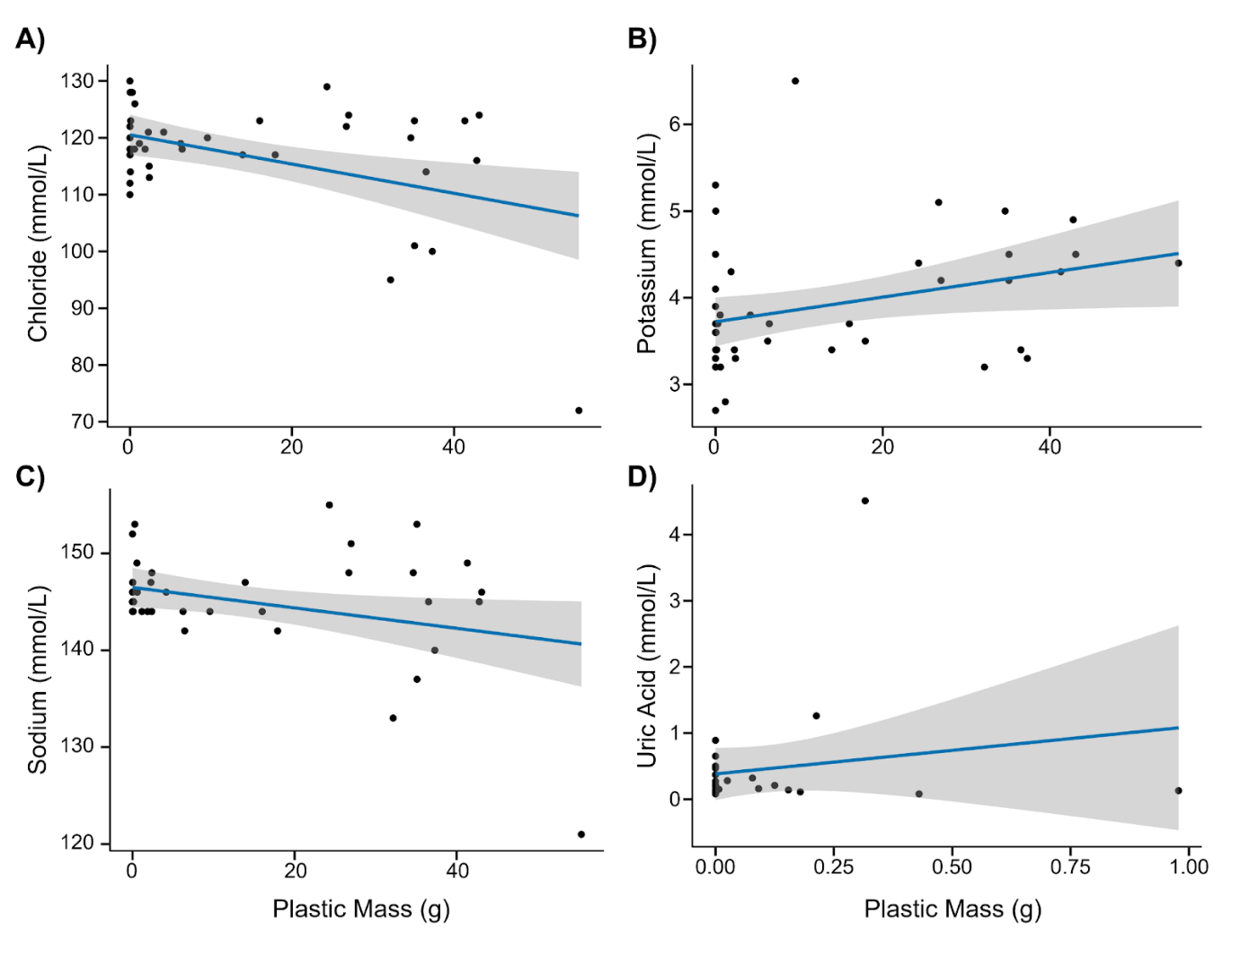
Figure 1. Linear regression analyses of blood chemistry parameters and ingested plastic mass (g) in Sable Shearwater fledglings. (A - C) Regression lines and confidence intervals for chloride, potassium, and sodium sampled in 2025. Relationship between uric acid and ingested plastic mass (D) based on data from 2014-2017 (adapted from Lavers et al. 2019).
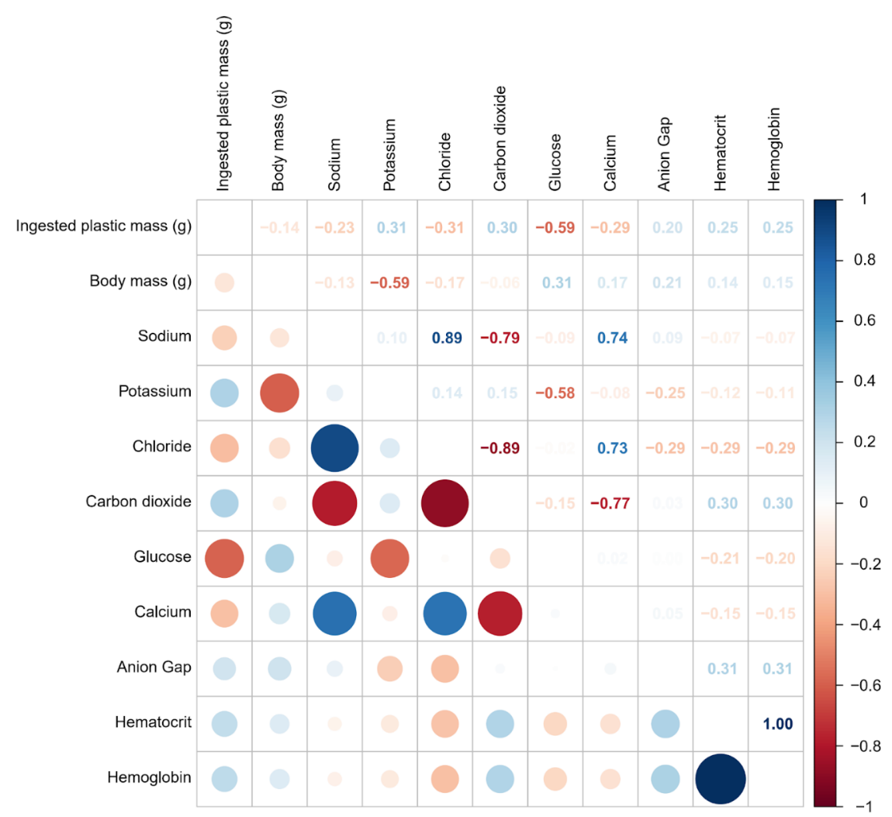
Figure 2. Correlation matrix depicting the relationships between ingested plastic mass, body mass, and blood chemistry parameters of fledgling Sable Shearwaters in 2025 (n = 43). The lower triangle displays correlations as coloured circles, with intensity and size indicating the strength and direction of associations, while the upper triangle shows numerical correlation values. This matrix highlights associations between plastic ingestion, body size, and blood chemistry parameters.
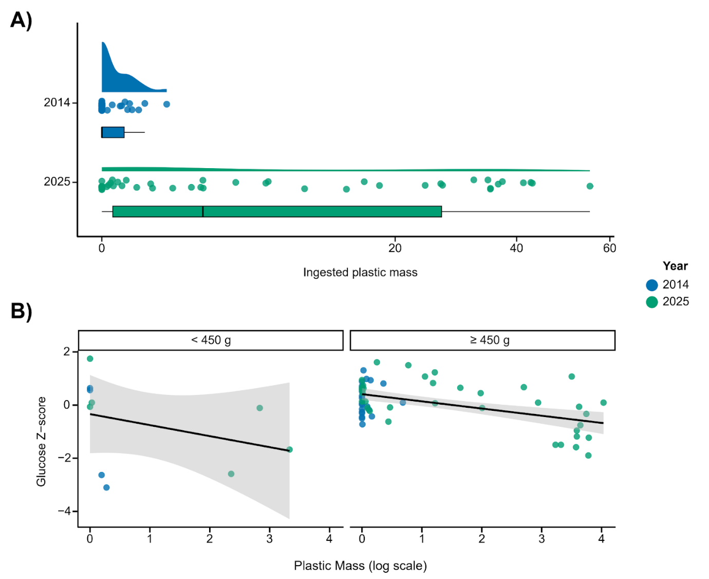
Figure 3. Plastic ingestion and glucose response in Sable Shearwaters across two sampling events (A) Distribution of ingested plastic mass in individuals sampled in 2014and 2025. (B) Linear regression of glucose Z-scored against log-transformed plastic mass, split by body mass groups. Groups are defined as Sable Shearwaters under 450 g (underweight) and those above 450 g (within normal range for this species). The negative association between plastic mass and glucose is consistent in both body mass groups, indicating that this physiological response is independent of bird size.
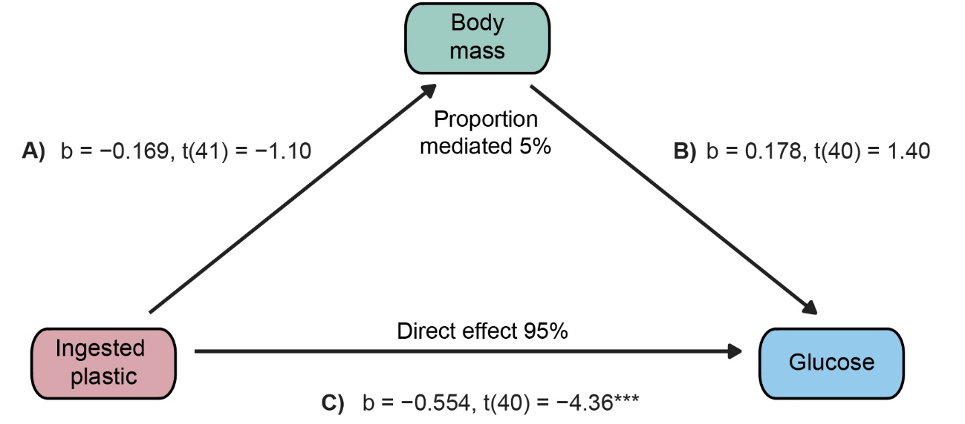
Figure 4. Mediation analysis testing the relationship between ingested plastic mass and blood glucose levels, with body mass included to assess its mediation. Path (A) represented the effect of ingested plastic mass on body weight, path (B) represents the effect of body mass on glucose, and path (C) indicates the direct effect of ingested plastic mass on glucose after accounting for body weight.

